**VALLEY BREEZE ARTICLE March 2017**

**LHS students bring awareness to dating violence**

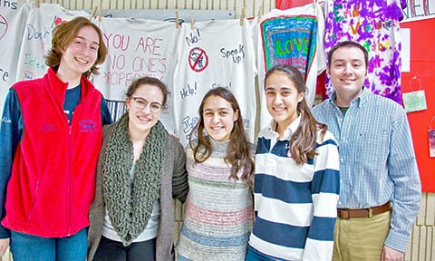

From left are Lincoln High School students Ailsa Ferland, Emilee Eastman, twins Allison and Samantha Leal and Ron Almeida, advisor to the school's National Honor Society group that organizes an awareness campaign each year about dating violence. Pictured above the group are T-shirts LHS students designed for the campaign, that are decorated with messages like 'Love isn't supposed to hurt.' (Breeze photo by Brittany Ballantyne)

LINCOLN – Dating violence can take the form of virtual abuse nowadays, through texting and social media, and Lincoln High School students are targeting that in this year’s awareness campaign. “People are very manipulative these days, because they have a screen in their face,” said Ailsa Ferland, a senior at the school. She explained that abuse can happen when someone constantly texts their partner, demanding to know why they aren’t answering, and using threatening language like, “Am I not more important than everything else?”

LHS students in the National Honor Society have continued an annual awareness campaign about dating violence through grant funding from the Lindsay Ann Burke Memorial Foundation. The group presents statistics to each advisory class in the school.

Ron Almeida, adviser to the Honor Society at LHS, cited data from the Department of Justice that shows 1 in 3 teenagers say they are texted between 10 and 30 times an hour by a partner keeping tabs on them. He also pointed out that new technology, like the app Find My Friends, a tracking app, can be dangerous in these scenarios. Almeida said of the campaign, “Hopefully, it brings awareness that any sort of violence, whether it be physical, emotional, psychological, is not OK.”

With the help of students in the journalism program, public service announcements are broadcast throughout the school about the dangers of relationship violence, and the Honor Society organizes a school-wide effort everyone can get involved in. Plain T-shirts are turned into works of art by students during advisory period, with students writing messages such as, “Love isn’t supposed to hurt.” The finished T-shirts are hung up inside the school to form a chain by the main entrance of the building as a daily reminder that help can be found at Lincoln High School. “It forces us to talk about an issue that, for some people, might be really uncomfortable – they don’t want to talk about it – and it allows us to talk not only with a teacher, but our peers,” said student Emilee Eastman, who said various levels of support are offered at LHS.

Ferland said it’s surprising how many people have been affected by abusive relationships, and said this campaign opens up that discussion of dating violence, “because even though we do talk about it, we don’t talk about it.”