Clothesline project highlights dating, domestic violence
April 2, 2017BRAND AND TOGGLE GET GROUPED FOR BETTER MOBILE DISPLAY
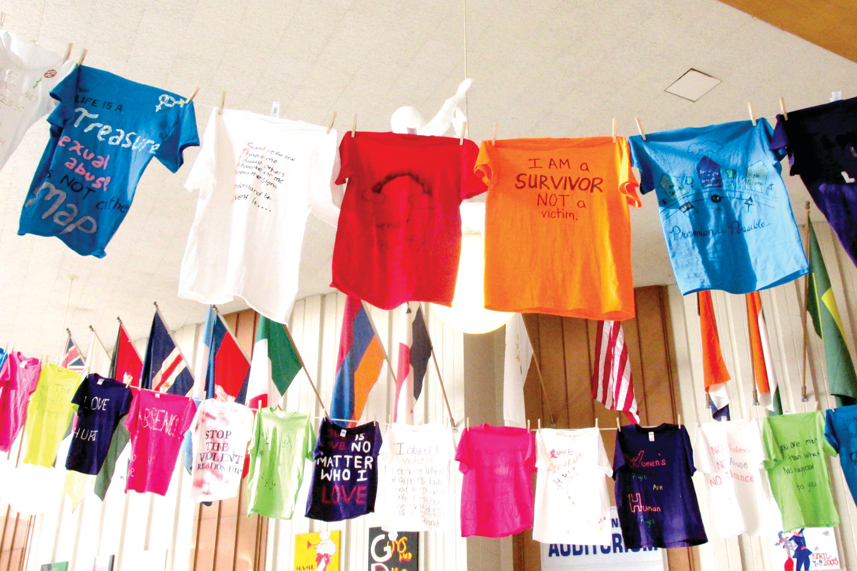
By Pete Fontaine
There’s a silent yet scary scene inside the foyer of the Johnston High School auditorium. Officially, it’s called the Clothesline Project, a month-long campaign sponsored by SADD (Students Against Dangerous Decisions) and designed to educate students about violence in dating that sometimes sadly ends in a death. “This may be one of the most important educational experiences of the academic year,” said Greg Russo, a JHS science teacher who serves as the SADD advisor. “Because February is Dating/Domestic Violence Awareness Month, we decided to take this subject to another level.”

Members of SADD made t-shirts in colors that represent various forms of domestic violence, like rape and battery due to sexual identity, for example. “The t-shirts had different messages and were worn by the SADD members on February 1,” Russo explained. “They then hung a clothesline in the auditorium foyer to display the t-shirts where they will remain hanging until the end of this month.”

Russo obtained a grant – which he explained was part of the Clothesline Project and is available through the Lindsay Ann Burke Memorial Fund – and invited a special speaker to JHS last Friday morning to speak about the horrors of Dating and Domestic Violence. The guest speaker was Ann Burke, whose daughter Lindsay Ann was murdered by her boyfriend after they broke up, who now serves as president of the non-profit that’s designed to stop such murders and support the prevention of all relationship violence. Burke addressed members of the JHS senior and junior classes last Friday morning inside the school’s auditorium, and as Russo and other faculty members who took in the presentation and accompanying slide presentation noted, “Although it was a saddening subject, you could hear a pin drop in the auditorium.”

SADD President Sofia Rengigas said, “She [Ann Burke] really connected with us. She made us realize the importance of dating violence.” So much so, in fact, SADD Vice President Nina Carnevale and secretary Paige Grenkiewicz concurred, saying, “It was absolutely sad to see all the pictures of the women and men who were killed. Just seeing their faces and how much of a loss of their life was that someone took away from them.” “This was a very educational presentation,” Rengigas said. “Mrs. Burke was extremely interesting; we know now what to look for when we see those warning signs.”

Burke told the JHS audience Lindsay became a typical victim of abuse and how her abuser turned murderer used every method to control her and every one present in their relationship. “Once our family and friends realized that something was terribly wrong, we all spoke with her and continued to do so, trying our best to help her to recognize the abuse and leave him,” Burke explained. “She had support from friends and family and still was murdered.” Ann Burke said her daughter “experienced all the psychological effects of abuse, almost all of them. After her death, even the police told us this was a classic case of abuse and that every aspect of her life was controlled by him. Being so young, inexperienced, compassionate, trusting and naïve, she became the perfect victim and he was the ultimate abuser.”

That’s why Ann started the Lindsay Ann Burke Memorial Fund, a non-profit founded to honor her daughter’s life as a 23-year-old and a Rhode Island College graduate from North Kingstown who was trying to break the cycle of violence when she was murdered. “Lindsay was an education major and came from a family of educators,” her mother said. “She was a compassionate, honest and trusting young woman who cared deeply for others. We believe she would want us to break the silence and work towards ending relationship violence through education.” The Lindsay Ann Burke Fund will support the prevention of relationship violence primarily through the education of teens, parents, educators and the public.
“I would like to commend members of the Johnston SADD Club and Mr. Russo for taking a leadership role to raise awareness of teen dating violence,” Ann Burke said. “They created and displayed t-shirts with powerful messages about dating violence. The students were a wonderful audience, asking thoughtful questions and engaged in meaningful discussion.”

Ann Burke, who said she was proud to give SADD the grant for the Clothesline Project, then concluded, “It was obvious to me that they learned a lot about the topic in their health classes and the students care about this important problem that affect one in five teens.”

